## The Role of Mood- and Concept Boards in Interior Design

In interior design, mood boards and concept boards play crucial roles in the creative process. These visual tools help designers to:

* Brainstorm, develop concepts and organise ideas to evaluate their effectiveness or visual impact against the brief.
* Explore and present visual design elements such as colour palettes, typography, imagery, and layout options to show how elements work together or convey a mood.
* Communicate a particular concept to a client in a tangible and visual way, making it easier for the clients to understand and provide feedback.
* Make final decisions and refinements. By presenting multiple boards side-by-side, you can offer more than one design solution so a client can make comparisons.
* Maintain consistency throughout a project by defining and presenting key design elements that you and/or team members can refer back to.

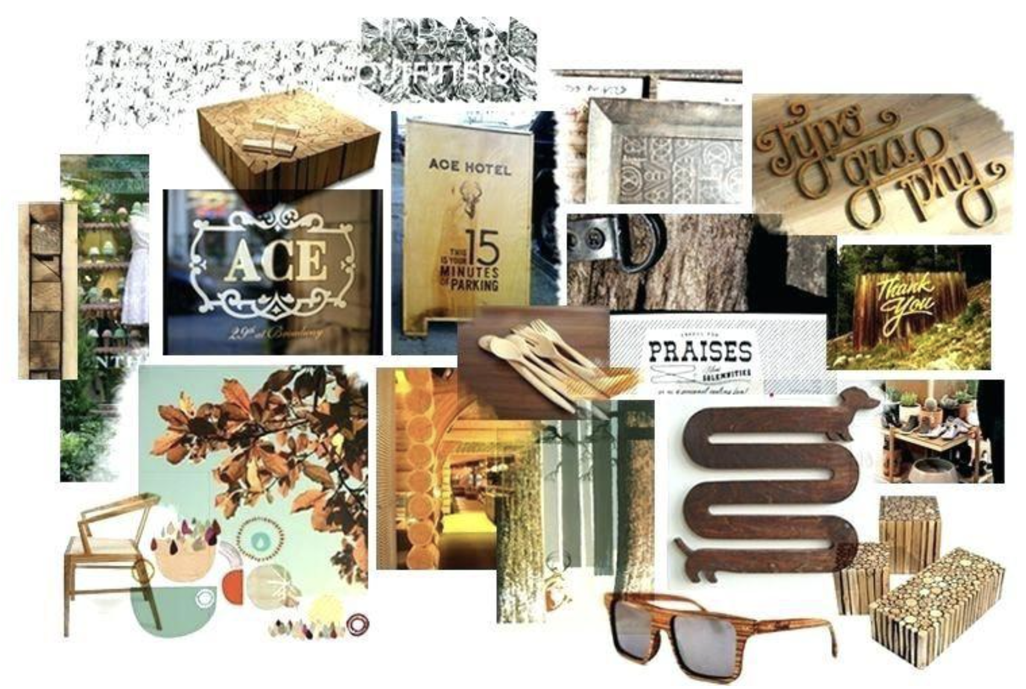

Fig 1. Concept board example

It is worth noting that mood or concept boards don’t typically contain an image, pattern, style or symbol that will appear exactly as is in the final design. These visual boards should generally illustrate an abstract depiction of the concept or feeling and style that the final design should reflect.

For example, a design for an upmarket studio apartment should not have the exact furniture, colour scheme, or accessories represented in the mood or concept board. However, there should be a relationship linking the visuals (e.g. images, photos, or sketches) with your final design. In other words, a mood or concept board could contain a photograph of plants and greenery symbolising a sense of serenity, purity and balance, which is then carried through to the final design by selecting a colour palette based primarily on grey and green hues, or a motif that resembles the shape of leaves.

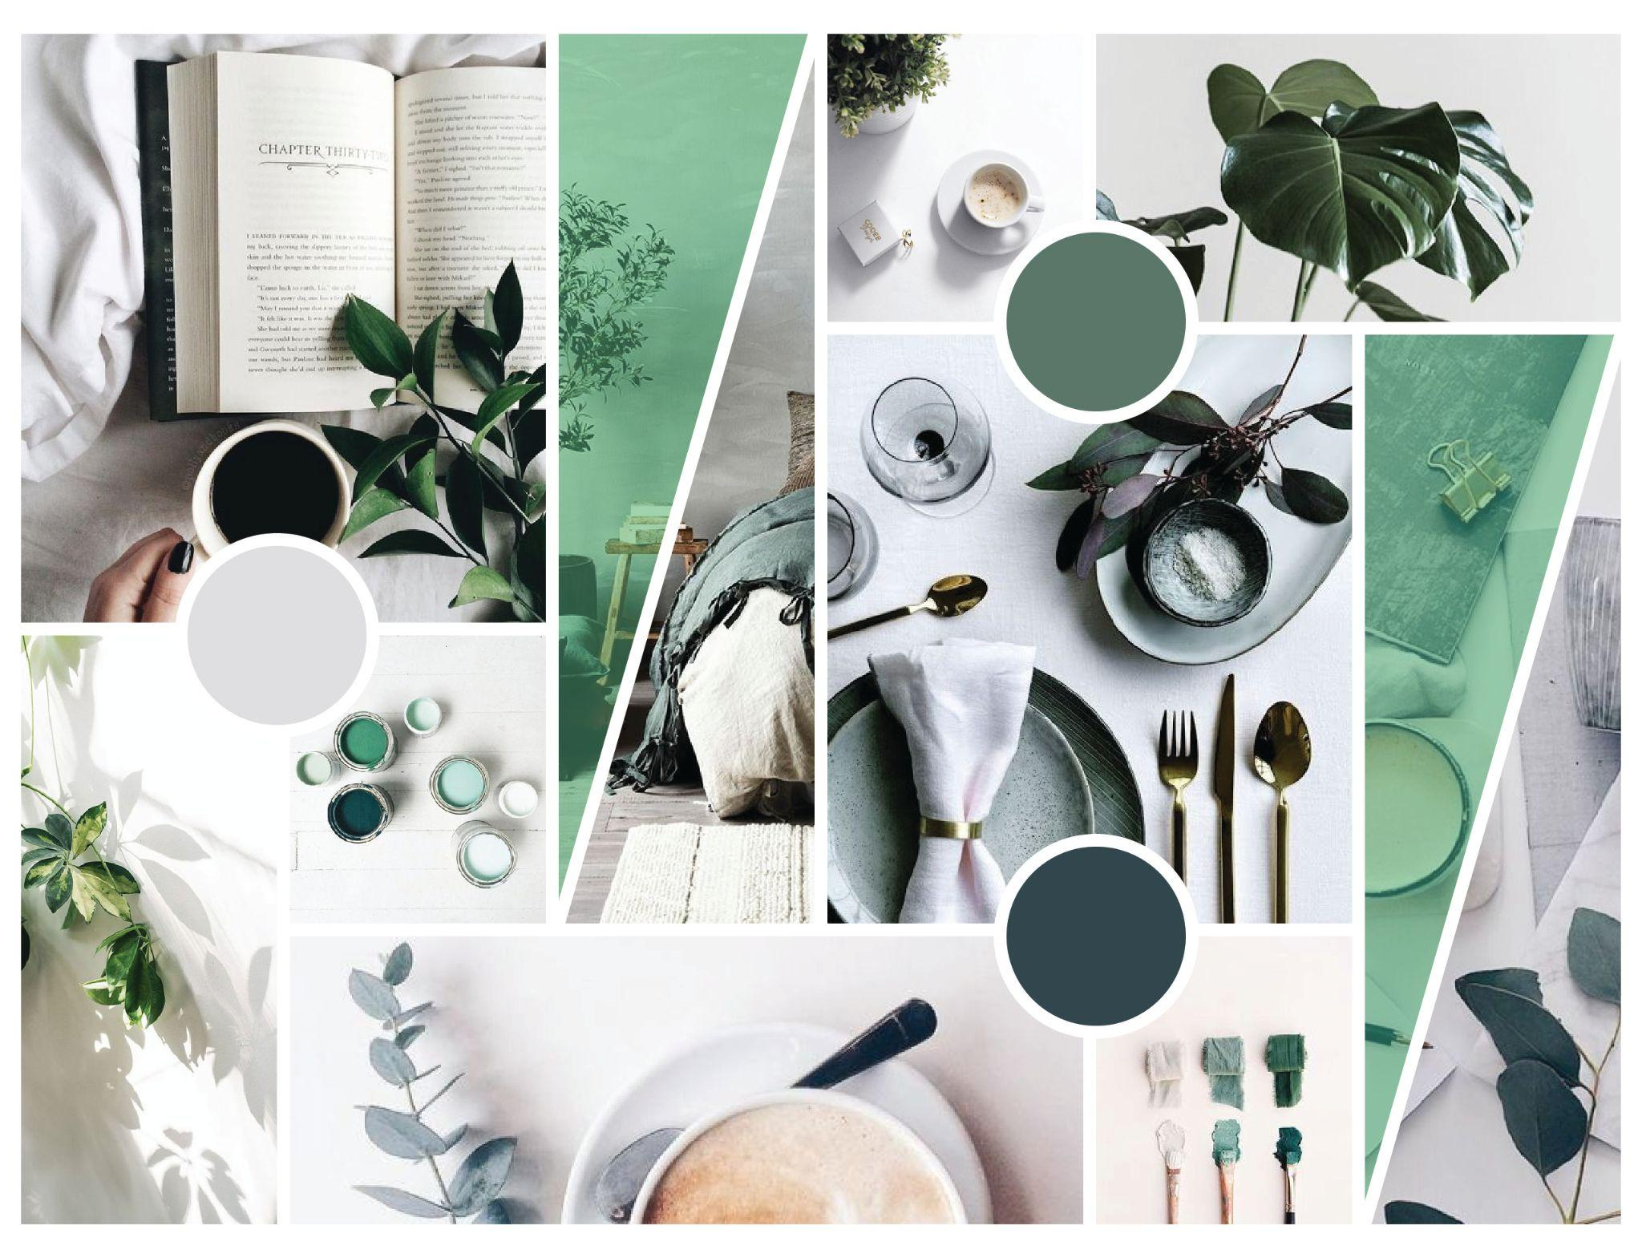

Fig 2. Concept board example

Overall, concept boards and mood boards are a valuable tool in design because they help streamline the creative process, improve communication, and ensure that the final design aligns with the project's goals and vision. They are a visual representation of the design concept and serve as a reference point throughout the design process.

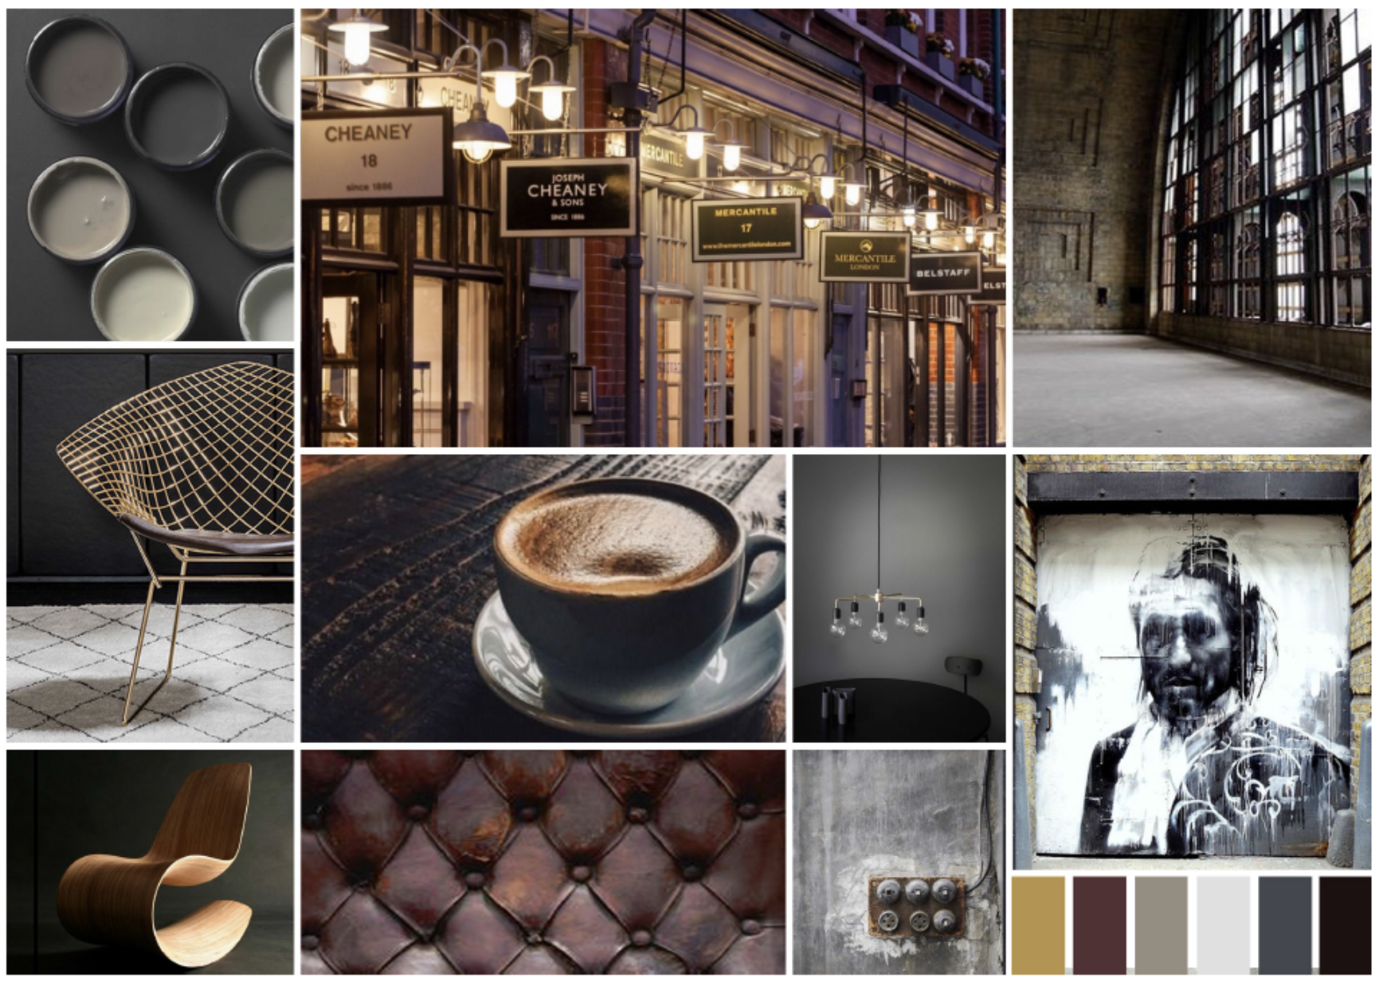

Fig 3. Mood board example

There is however, a difference between a concept board and a mood board. Both boards are closely related design tools, but they each serve a slightly different purpose and focus on distinct aspects of a design project.

## The Difference Between a Mood Board and a Concept Board

### Purpose

Mood boards, emphasise the emotional or visual tone of a design project. Using a selection of images, colours, textures, and typography, it is more focused on evoking a particular mood, feeling, or atmosphere, hence the name. A mood board helps establish the aesthetics and ambiance of the design.

Concept boards focus primarily on conveying the core idea, message, or concept behind a design project. It emphasises the overall creative direction, including the main theme, visual style, and design concept. It aims to represent the "big picture" of the project.

### Emphasis

A mood board’s primary emphasis is on the emotional aspects of the design. It helps establish the look and feel of the design, focusing on the aesthetics and moodthat emanate fromthe selection of images, shapes, colours, textures, etc. These samples combined, help establish the ambiance of the design.

The main focus of a concept board is on the conceptual and strategic aspects of the design. It helps define the purpose, message, and key elements of the design. It may include elements that directly relate to the project's central concept or idea, like key visuals, symbols, or design elements that are essential to conveying the intended message.

### Usage

Mood boards are generally used for inspiration and to set the visual tone at the beginning of a design project. They help designers and clients get on the same page regarding the project's overall mood and style.

Concept boards are also used in the early stages of a design project to outline the main concept and direction. They are useful for presenting ideas to clients or stakeholders for feedback and for guiding the design process to the end.

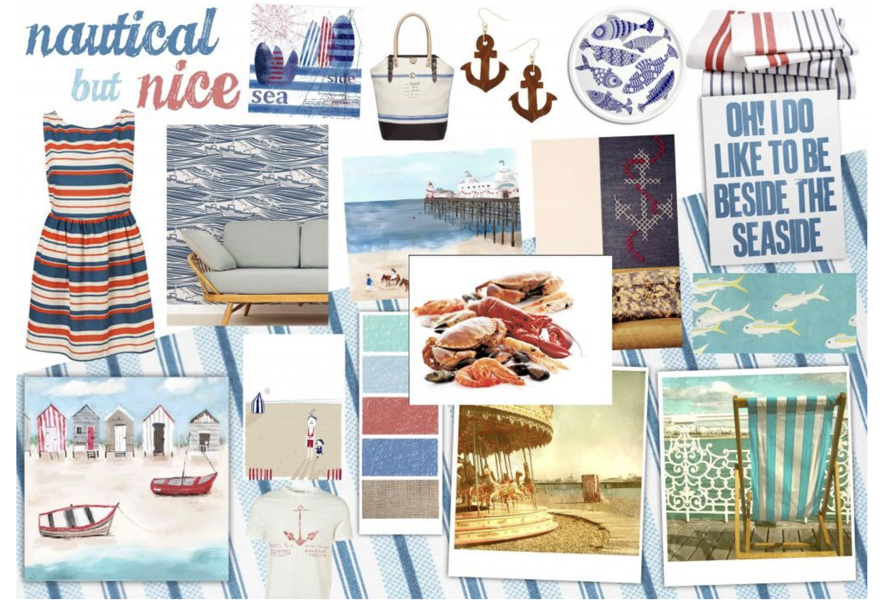

Fig 4. Mood board example

## Creating a Mood or Concept Board

Mood boards and concept boards are key visuals that are created during the ideation and iteration stages of the design process. They play an important role during brainstorming for example, and for reviewing a concept for further development. They also serve as useful mediums to present a concept to various stakeholders for feedback.

Here are some key steps to creating a mood board or a concept board:

* **Step 1:** Analyse the brief so that you understand the project’s objectives, target audience, message, and any other requirements.
* **Step 2:** Research and gather inspiration and visual and/or textural elements that relate to your project. This could include images, graphics, illustrations, symbols, key words, colour swatches, or hard and soft material samples that align with the project's theme or concept.
* **Step 3:** Decide on the format of your board, i.e. digital or actual board. For physical boards, an A3 size or larger should suffice to showcase your visuals. If you are creating a digital board, use tools like Adobe Photoshop or Illustrator or free alternatives like Gimp or Krita.
* **Step 4:** Organise a layout and arrange the chosen visual elements accordingly. Consider factors like composition, balance, and hierarchy. If you are creating a physical board, your visuals should be neatly cut using a scalpel and cutting mat. And remember to first play around with your layout before glueing anything down!
* **Step 5:** Include concise, clear, and well-written captions or explanatory text that accompanies each visual element. These captions should explain how each element contributes to the concept and message. Remember to emphasise the imagery and not the text so that your board appears appropriately sized and balanced.
* **Step 6:** Ensure that all the visual elements satisfy the design brief and are consistent in terms of style, colour, and overall aesthetic. This helps reinforce the mood or design concept.

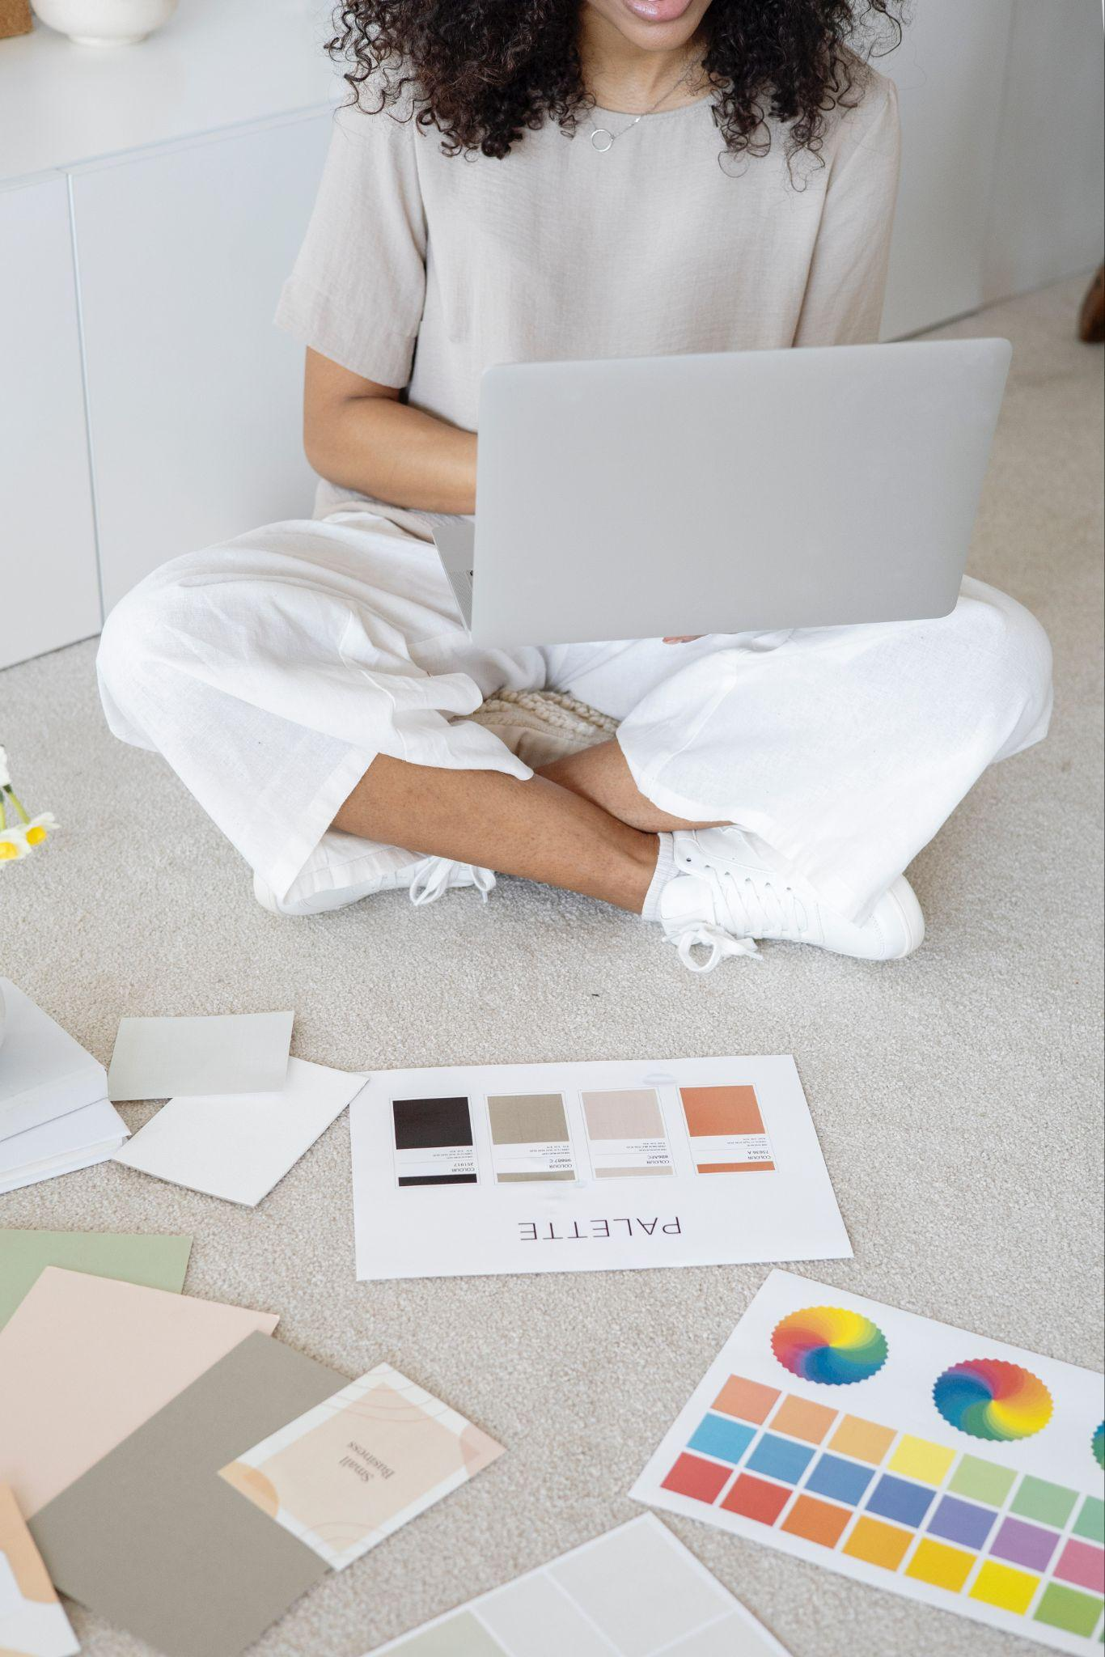

Fig 5. Unsplash (n.d.) Visuals for physical concept board